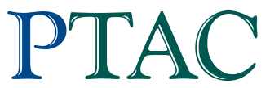
Preliminary Information
PTAC is working with NRC-IRAP ITAs to identify SMEs and projects that will provide benefits to the Canadian Oil and Gas Industry
* Required
SME Name *

Name of primary contact *

Phone number of primary contact *

Email of primary contact *

Are you currently an IRAP client? *
Yes
No
If you answered yes to the previous question, who is your industrial technology advisor?

What is your Innovation or Product? *

What do you offer that Industry needs and no one currently offers? *

What is the TRL of your innovation? (2-3 sentences) *

